Contents

**History of Eid ul-Adha** 1

**Introduction** 1

**1. The Story of Prophet Ibrahim (A.S.)** 1

**2. Establishment of Eid ul-Adha** 2

**3. Religious and Social Significance** 2

**4. Rituals and Sunnah of Eid ul-Adha** 2

**5. Eid ul-Adha and the Hajj Connection** 2

**Conclusion** 3

References 3

**History of Eid ul-Adha**

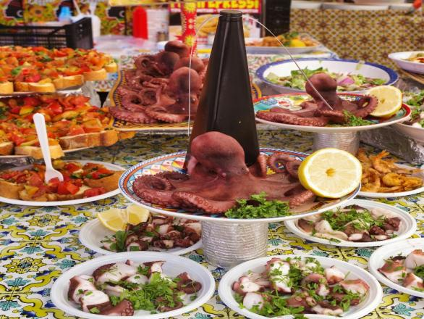**Introduction**

Eid ul-Adha, also known as the "Festival of Sacrifice," is one of the two major Islamic holidays celebrated by Muslims around the world. It commemorates the willingness of Prophet Ibrahim (Abraham, peace be upon him) to sacrifice his son Ismail (Ishmael) as an act of obedience to Allah’s command. Eid ul-Adha is observed on the 10th day of Dhul-Hijjah, the last month of the Islamic lunar calendar, and coincides with the Hajj pilgrimage.

**1. The Story of Prophet Ibrahim (A.S.)** The roots of Eid ul-Adha trace back to the time of Prophet Ibrahim. According to Islamic tradition, Allah commanded him in a dream to sacrifice his beloved son, Ismail. Without hesitation, Ibrahim prepared to fulfill the command. However, at the last moment, Allah replaced Ismail with a ram, rewarding Ibrahim’s faith and devotion.

**Key Points:**

* Based on the Qur'anic account in Surah As-Saffat (37:102–107).
* Demonstrates ultimate obedience and trust in Allah.
* Ismail’s life was spared and a ram was sacrificed instead.

**2. Establishment of Eid ul-Adha**

Eid ul-Adha was established during the time of Prophet Muhammad (peace be upon him) as part of the rituals of Hajj. It became a key religious holiday observed with a special prayer and the symbolic sacrifice of animals such as goats, sheep, cows, or camels.

**Key Points:**

* Instituted in the second year after Hijrah (migration to Medina).
* Associated with the Hajj pilgrimage and rites at Mina.
* Muslims who are not performing Hajj also observe the festival globally.

**3. Religious and Social Significance**

Eid ul-Adha is a time of reflection, sacrifice, and generosity. The act of sacrificing an animal reminds Muslims of the importance of submission to Allah and the willingness to give up what is most valuable for His sake. The meat from the sacrifice is divided into three parts: one for the family, one for relatives and friends, and one for the poor and needy.

**Key Points:**

* Highlights selflessness and devotion to God.
* Emphasizes helping the less fortunate.
* Promotes unity among Muslims worldwide.

**4. Rituals and Sunnah of Eid ul-Adha** The celebration of Eid begins with a special congregational prayer held in mosques or open fields. Muslims wear their best clothes, perform the Eid prayer, listen to the khutbah (sermon), and then carry out the sacrifice.

**Key Points:**

* Eid prayer consists of two Rak'ahs followed by a sermon.
* Sacrifice is performed after the prayer, not before.
* Takbeer is recited from the morning of 9th Dhul-Hijjah until the 13th.

**5. Eid ul-Adha and the Hajj Connection**

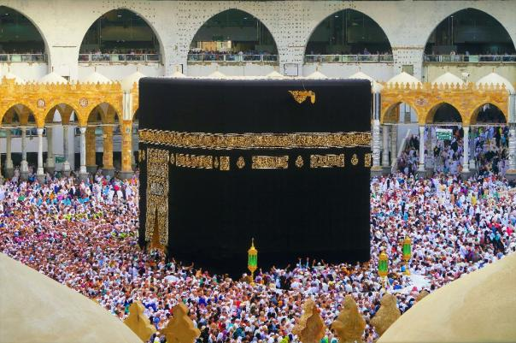The festival is closely linked to the annual pilgrimage (Hajj), specifically the events that take place at Mina and Mount Arafat. Pilgrims perform the symbolic stoning of the devil and offer their own sacrifice on the same day.

**Key Points:**

* Eid marks the climax of Hajj rites.
* Celebrated by all Muslims, but especially significant for pilgrims.
* Symbolizes spiritual purification and commitment to Allah.

**Conclusion**

Eid ul-Adha is more than just a ritual of sacrifice—it is a celebration of faith, obedience, and compassion. Rooted in the legacy of Prophet Ibrahim (A.S.), this festival continues to unite Muslims in worship and charity. By remembering the trials of Ibrahim and Ismail, Muslims are reminded of the power of faith and the importance of submission to God’s will.

Here are appropriate references you can include for your two-page write-up on the **History of Eid ul-Adha**. These sources are reliable and relevant for academic or general use.

### **References**

1. **The Holy Qur’an**
   * Surah As-Saffat (37:102–107): Narrates the story of Prophet Ibrahim and his son Ismail, the foundation of Eid ul-Adha.
2. **Sahih al-Bukhari**
   * Book of Eid Prayers and the Book of Sacrifices: Contains Hadith about the Prophet Muhammad’s (PBUH) practices during Eid ul-Adha.
3. **Al-Mubarakpuri, S. R.** (1996). Ar-Raheeq Al-Makhtum (The Sealed Nectar). Darussalam Publishers.
   * Offers historical context on the establishment of Islamic festivals during the Prophet’s lifetime.
4. **Esposito, J. L.** (2003). The Oxford Dictionary of Islam. Oxford University Press.
   * Provides definitions and background on Hajj and Eid ul-Adha.
5. **Nasr, S. H.** (2003). Islam: Religion, History, and Civilization. HarperOne.
   * A scholarly overview of Islamic rituals, including the significance of Eid ul-Adha.
6. **Waines, D.** (2003). An Introduction to Islam. Cambridge University Press.
   * Discusses Islamic festivals and their spiritual meaning.